Man-Size in Marble by E Nesbit retold by Kieran McGovern
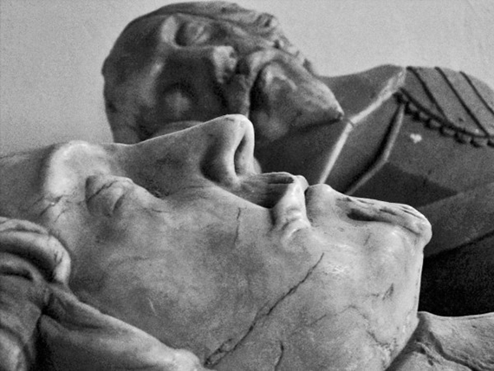
The church was large and lonely but we loved to visit it, especially on bright nights. To get there we followed ‘the cemetery walk’. This was a long path through a dark wood. It was once used to carry dead bodies to the church.
Inside, the church was dark and gloomy. On each side of the aisle there was a grey marble statue of a knight.
‘Mrs. Dorman says they should not be here,’ Laura told me. ‘She says that they were wicked men.’
‘Why are there statues of them?’
‘She says they were wealthy men. They bought their place in the church with stolen gold.’
Looking at their hard faces this story was easy to believe.
***
Vocabulary
aisle - walkway down centre of church
grave - hole dug in the ground to bury a dead body
cemetery/graveyard - where bodies are buried
gloomy - poorly lit, depressing
marble - hard, smooth material used for statues, columns etc.
wealthy - to have money and property
wicked - bad/evil
Quick Check: True or false?
- The ‘cemetery walk’ leads to the church.
- The ‘cemetery walk’ is gloomy on bright nights
- Marble is a smooth form of stone.
- Mrs Dorman is a wicked woman.
- The knights became rich through crime.

